In Table 3, team distance and opponent distance both exhibit statistically significant effects when considered individually. However, the posterior ridge plot shows that these coefficients are strongly negatively correlated, indicating substantial multicollinearity. As a result, many different coefficient combinations yield similar fitted values–for example, a large negative effect for team distance combined with a large positive effect for opponent distance produces the same outcome as smaller effects of opposite sign. This makes the separate interpretation of the two coefficients unreliable. Examining their combined effect reveals that the sum of both coefficients is weakly identified, with substantial posterior mass around zero. To address this identification issue, the distance ratio should be used as a single summary measure. The posterior distribution of this ratio places most probability mass above zero, indicating a positive association despite still including zero.
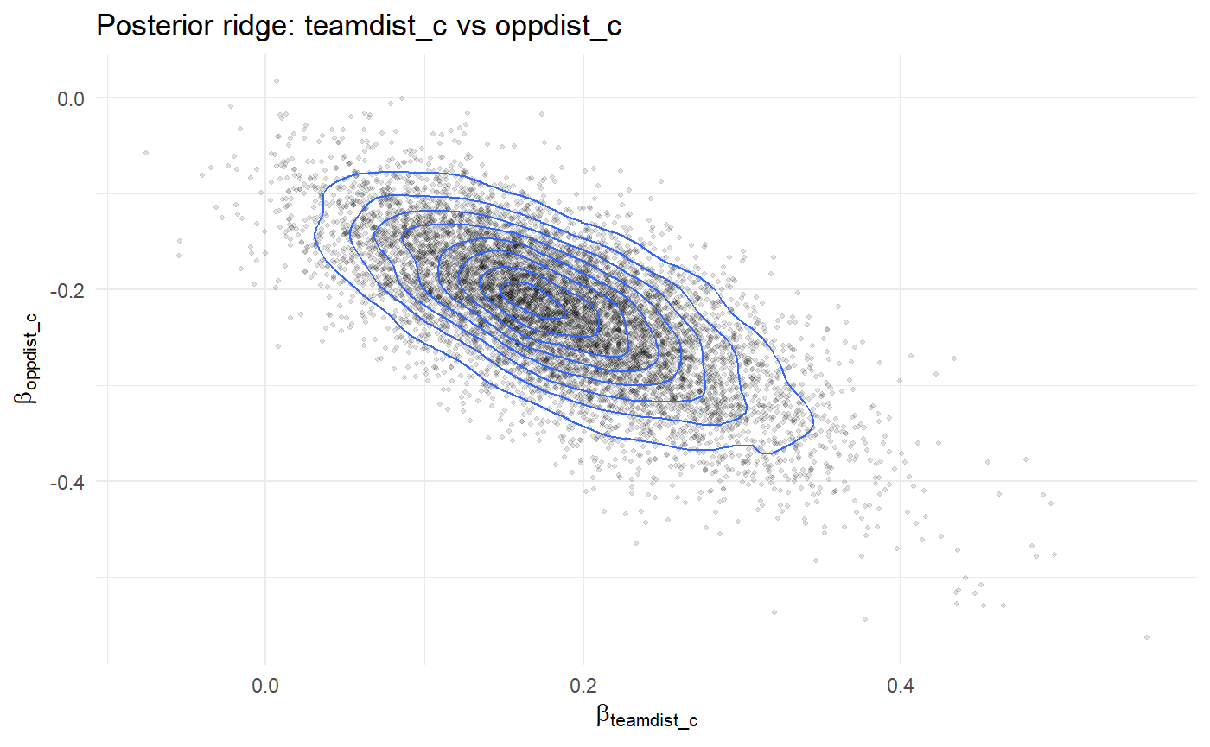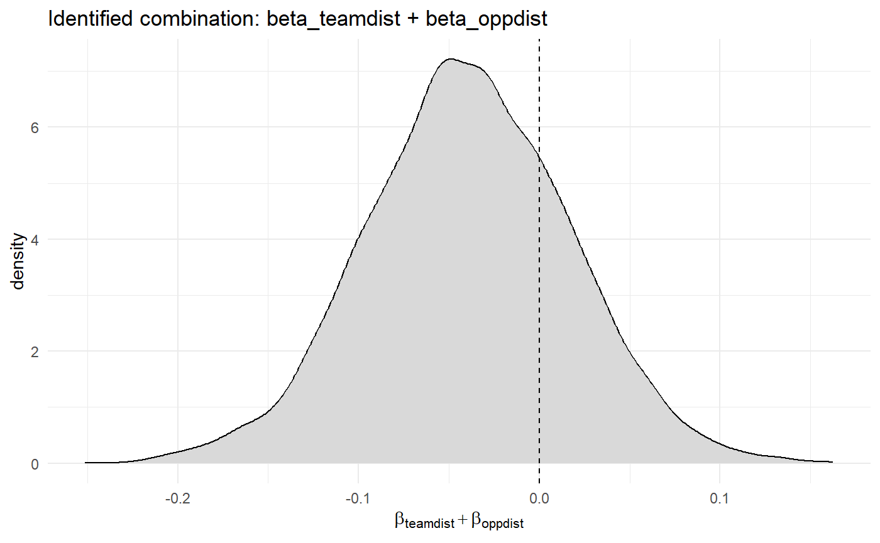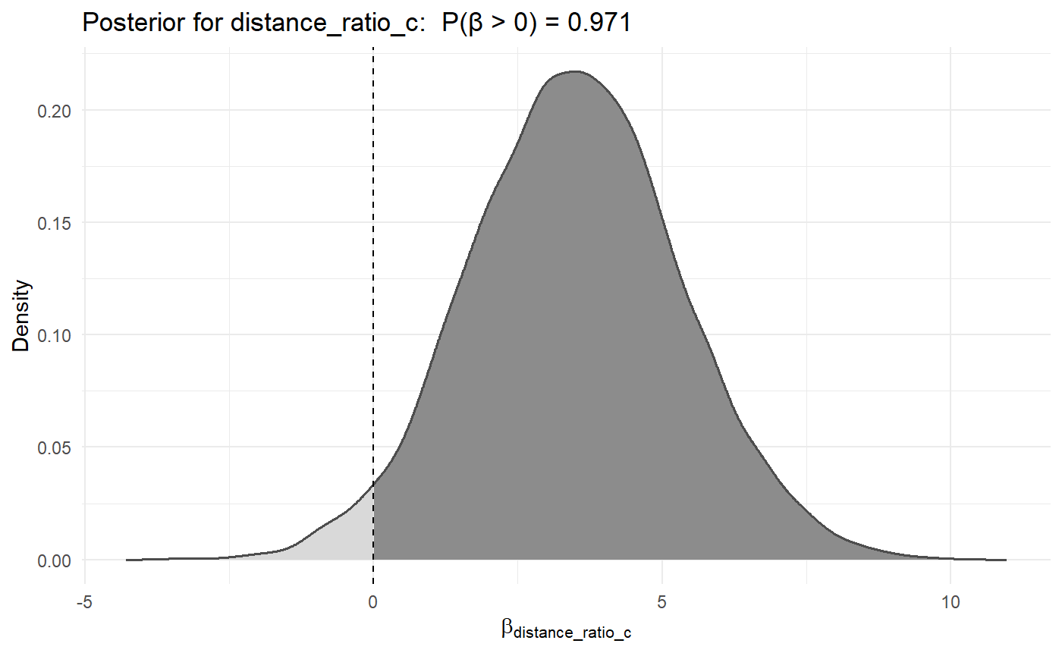

Table 3: multicollinearity
Because these two predictors are correlated, the model struggles to decide how to split the total effect between them. a clear negative correlation between coefficients. Multicollinearity does not prevent estimation of the total effect, but it weakens the ability to identify how that effect is distributed across correlated predictors. Small changes in one coefficient can be compensated by changes in another with little loss of fit.
posterior ridge plot already shows it: the data can’t distinguish which distance gets the effect, so the posterior allows a “swap”: more positive for one, more negative for the other.
OLS takes the best one minima, bayes can look at the whole valley, and sees that many have similar explanatory power and thus reduces
Because team and opponent distance are strongly correlated, their separate coefficients exhibit a ridge (trade-off) and are difficult to interpret individually. We therefore use distance_ratio_c as a single summary of relative distance, which reduces this identification problem and yields a clearer posterior signal.

Conclusion:

This paper replicates key elements of the preliminary analyses in Cohen-Zada et al. (2023) using a Bayesian framework and finds broad qualitative agreement with the original results. Effect directions and relative magnitudes are largely preserved, though estimates are generally less pronounced and associated with wider uncertainty. Sensitivity analyses indicate that the individual-level results (Table 2) are robust to prior choices and primarily driven by the data, whereas the team-level effects (Table 3) are more sensitive to the degree of regularization and emerge only under very weakly informative priors.

In addition, the Bayesian framework allows the outcome to be modeled in a way that directly reflects its probabilistic nature. Rather than relying on linear probability models estimated by OLS, we model events using a Bernoulli likelihood with a logistic link function, ensuring predicted probabilities remain bounded between zero and one and aligning inference with the discrete structure of the data.

The key contribution of the Bayesian approach lies in how the data structure is modeled. The original analysis relies on fixed effects with clustered standard errors, which account for group-specific heterogeneity and adjust statistical significance for within-group dependence. However, group effects are estimated independently, and clustering affects only standard errors and p-values, leaving the coefficient estimates themselves unchanged. Bayesian multilevel models, by contrast, explicitly model the hierarchical structure of the data through partial pooling. Player, team, and five-minute section effects are estimated jointly, allowing information to be shared across groups. This stabilizes estimates, especially for sparsely observed units, and reduces extreme values driven by noise.

This distinction is particularly relevant in a football context. Observations within the same team or five-minute section are not independent: players act under shared tactical instructions, formations, match states, and motivational conditions. Treating such effects as fully independent ignores these dependencies, whereas partial pooling reflects the expectation that players facing similar situational constraints behave similarly, while still allowing for individual differences supported by the data.

This distinction is not merely conceptual but critical for Table 3. With roughly 200 observations and a number of fixed effects of comparable magnitude, the fixed-effects specification becomes severely oversaturated and poorly identified, yielding unstable and unreliable estimates. In this setting, partial pooling is not merely a modeling improvement but a statistical necessity.

Beyond this, we explicitly assess model generalizability using leave-one-out cross-validation, an evaluation step not undertaken in the original paper. This allows models to be compared based on out-of-sample predictive performance rather than in-sample fit. Unlike R², which measures in-sample fit and does not assess predictive performance, LOO is explicitly designed to evaluate how well a model generalizes to new data. In Table 2, this analysis confirms that hierarchical specifications achieve superior predictive performance relative to fixed-effects models, reinforcing the advantages of the Bayesian approach.

Finally, Bayesian inference provides a more transparent characterization of uncertainty. Credible intervals allow direct probabilistic statements about parameters conditional on the observed data, in contrast to confidence intervals, which describe long-run properties of hypothetical repeated samples .

Overall, our Bayesian replication leads to the same qualitative conclusions as the corresponding preliminary analyses in Cohen-Zada et al. (2023) at the individual level: individual effort is positively associated with individual performance (Table 2). At the team level (Table 3), we only find evidence of a positive association between team effort and team performance under very weakly regularizing prior specifications, indicating that this result is more sensitive to modeling assumptions. In both cases, estimated effects are smaller in magnitude and accompanied by greater uncertainty, resulting in weaker statistical evidence than reported in the original analysis.

Für Overleaf:
In order to replicate the alphabetical sorting used by Cohen-Zada et al. (2023) in later models, we added the variable hebrew_name to the dataset. The variable played represents a running count of games played and was used to identify the end of the regular season, while team_rank denotes each team’s position in the season table and serves as a unique team identifier at that point. Using these variables, we matched each team to its corresponding Hebrew team name from the final regular-season standings collected from Wikipedia (2017–18 Israeli Premier League).

Prior reasoning
Table 2
Column 1
# default for all coefficients (no change)
set_prior("normal(0, 0.4)", class = "b")
We are saying that each dummy changes the probability to score a goal to be between 0.45% and 2.18%.
# Speed (reduced effect to adjust for it having 12 units)
set_prior("normal(0, 0.08)", class = "b", coef = "plaavspeed_c")
We are saying that running at top speed 12km/h changes the probability to score compared to 0km/h to be between 0.1% to 6.4%.

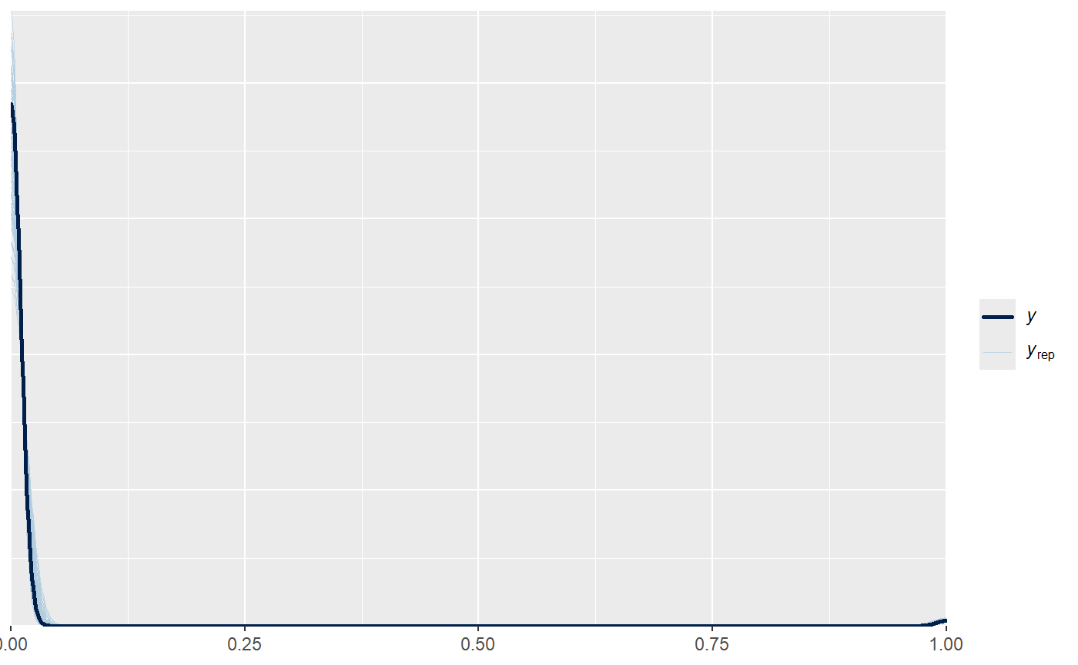
Prior only pp_check von column 1. Looks good, some lines predict less goals, some predict more goals. The black line is in the middle of our priors, so know general trend of it being above or below black.

Column 2
Alt:
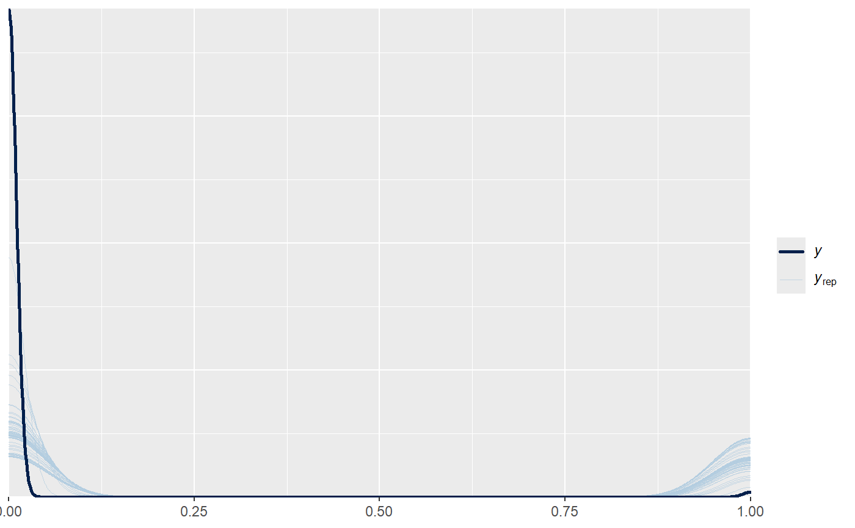
Irgendwas stimmt hier nicht. Es wird viel zu oft Goal geschätzt und zu selten 0. Sieht für mich aus wie 50/50 Chance diese priors sind zu wide.

# dhomegame is binary for if it is a homegame
set_prior("normal(0, 0.4)", class = "b", coef = "dhomegame")
We are saying that playing at home changes the probability to score to between (0.0045 ; 0.0218) so 0.45% to 2.18%.

# rankgap, goes from -13 to 13 (reduced effect to adjust for it having 26 units)
set_prior("normal(0, 0.045)", class = "b", coef = "rank_gap_c"),
We are saying that playing someone that is 13 positions under you changes the probability to score compared to playing someone 13 position above you between (0.0009 ; 0.094) so 0.0% to 9.4%.

# player_cumsections goes from 1 to 19. (reduced effect to adjust for it having 19 units)
set_prior("normal(0, 0.06)", class = "b", coef = "player_cumsections_c")
We are saying that playing 19 sections cumulatively changes the probability to score compared to playing only one section between (0.0009 ; 0.088) so 0.01% to 8.8%.

# player_cumsections_2 is quadratic and goes from 1 to 361 (reduced effect to adjust for it having 361 units)
set_prior("normal(0, 0.003)", class = "b", coef = "player_cumsections_2_c")
We are saying that playing 361 squaredsection-units cumulatively changes the probability to score compared to playing only one squaredsection-unit between (0.0011 ; 0.079) so 0.01% to 7.9%.
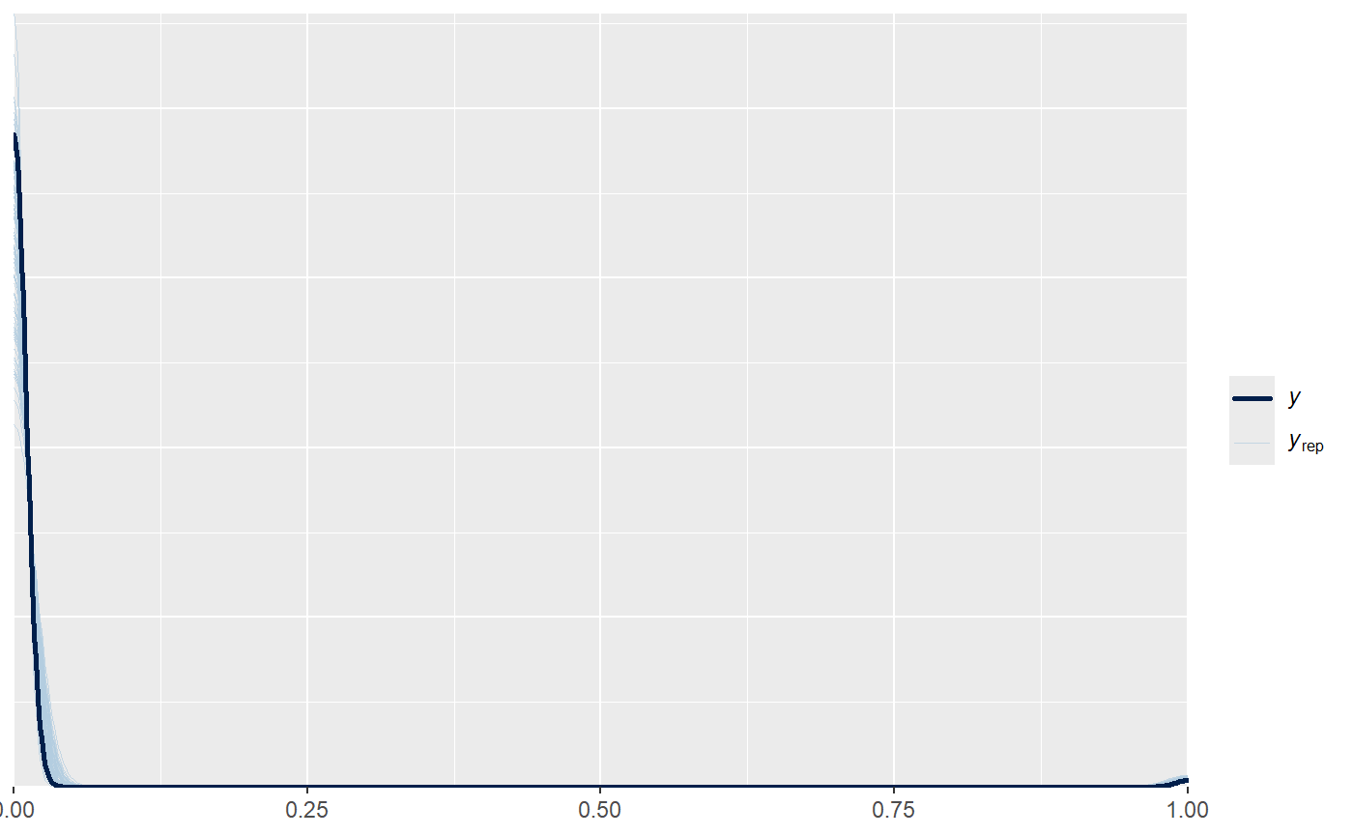
Jetzt sieht das wieder nice aus.

Column 3
Alt:
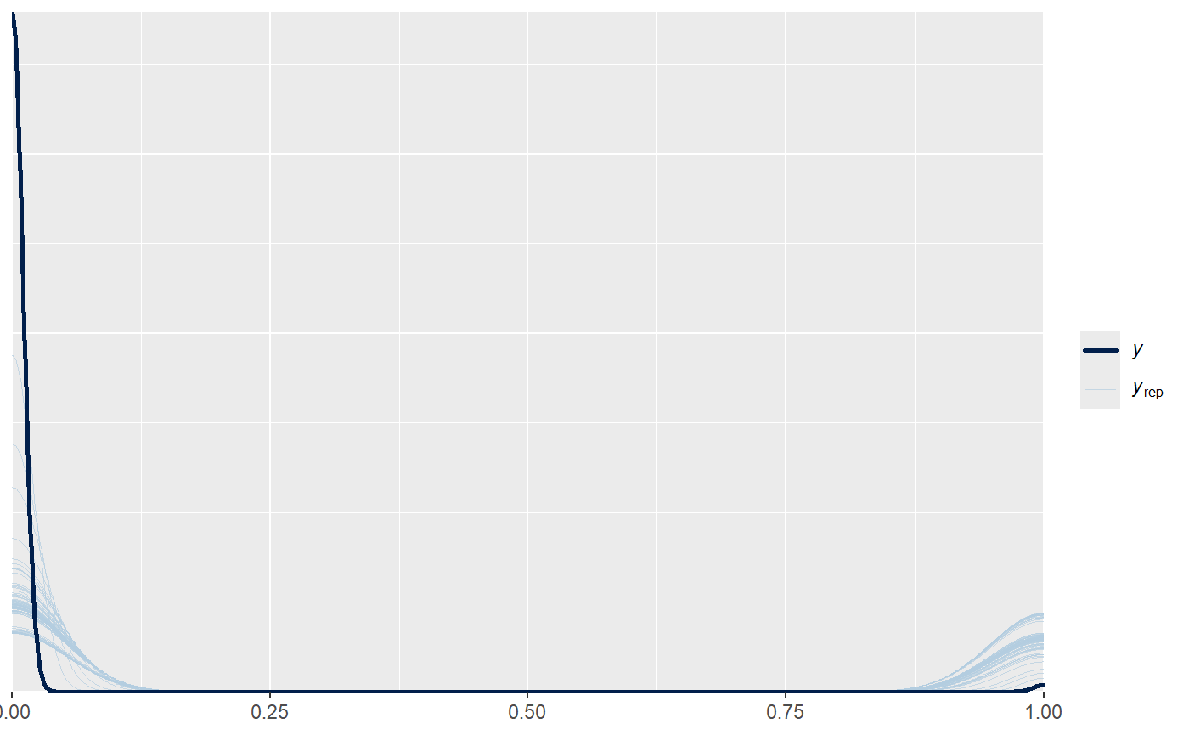
Too wide.

# scoregap_pre goes from -4 to 4 (reduced effect to adjust for it having 8 units)
set_prior("normal(0, 0.15)", class = "b", coef = "scoregap_pre_c")
We are saying that having a score advantage of 4 goals changes the probability to score compared having 4 less goals than the oppononte to between (0.009 ; 0.098) so 0.01% to 9.8%.

# dteamgoal_pre goes from 0 to 1
set_prior("normal(0, 0.4)", class = "b")
We are saying that scoring a goal in the section before changes the probability to score a goal to be between 0.45% and 2.18%.

# dplagoal_pre goes from 0 to 1
set_prior("normal(0, 0.4)", class = "b")

We are saying that scoring a goal yourself in the section before changes the probability to score a goal to be between 0.45% and 2.18%.

#dteamred_pre goes from 0 to 1
set_prior("normal(0, 0.4)", class = "b")
We are saying that your team getting a red card in the section before changes the probability to score a goal to be between 0.45% and 2.18%.

#dteamminj_sec_pre goes from 0 to 1
set_prior("normal(0, 0.4)", class = "b")
We are saying that your team getting a injury in the section before changes the probability to score a goal to be between 0.45% and 2.18%.

# team_avespeed_pre_c goes from 0 to 49 (reduced effect to adjust for it having 49 units)
set_prior("normal(0, 0.025)", class = "b", coef = "team_avespeed_pre_c")
We are saying that a team running 49km/h in the section before changes the likelyhood of scoring agoal compared to team running 0km/h between (0.0008 ; 0.103) so 0.01% to 10,3%.
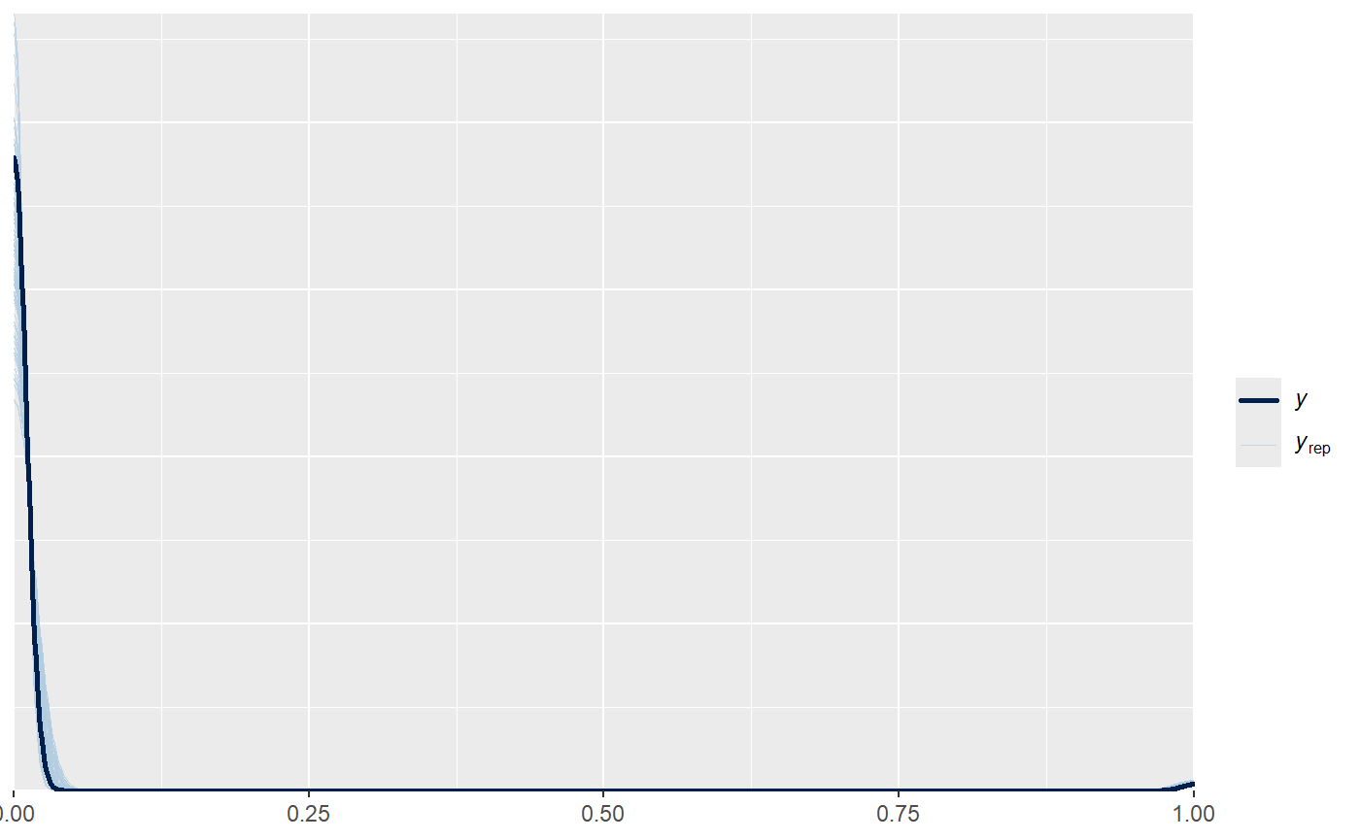
Wieder gut.

Column 4

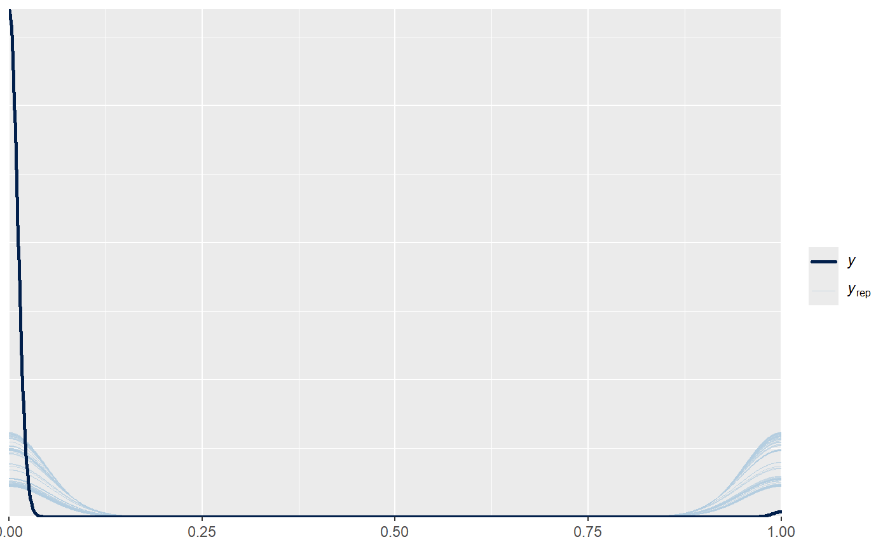
Wieder zu oft 1 geschätzt.

# team_crowd goes from 6 to 25180 (reduced effect to adjust for it having 25174 units)
set_prior("normal(0, 4.8e-05)", class = "b", coef = "team_crowd_c")
We are saying that a team having 25180 home crowd members changes the probability of scoring a goal compared to having 6 homecrowd members by (0.0008 ; 0.10) so 0.01% to 10%.

# opp_crowd goes from 6 to 25180 (reduced effect to adjust for it having 25174 units)
set_prior("normal(0, 4.8e-05)", class = "b", coef = "opp_crowd_c")
We are saying that a team having 25180 opp crowd members changes the probability of scoring a goal compared to having 6 oppcrowd members by (0.0008 ; 0.10) so 0.01% to 10%.

# p_odds_team goes from 0.05 to 0.8, so 0.75 units (increased effect to adjust for having only 0.75 unit)
set_prior("normal(0, 1.5)", class = "b", coef = "p_odds_team_c")
We are saying that a team having as 0.75 chance of wining compared to 0.05 changes the probability of a goal to be between (0.00q ; 0.08) so 0.01% to 8.6%.

# p_odds_draw goes from 0.14 to 0.33, o 0.19 units (increased effect to adjust for having only 0.19 unit)
set_prior("normal(0, 2.5)", class = "b", coef = "p_odds_draw_c")
We are saying that a team having as 0.33 chance of an draw compared to 0.14changes the probability of a goal to be between (0.003 ; 0.025) so 0.03% to 2.5%.

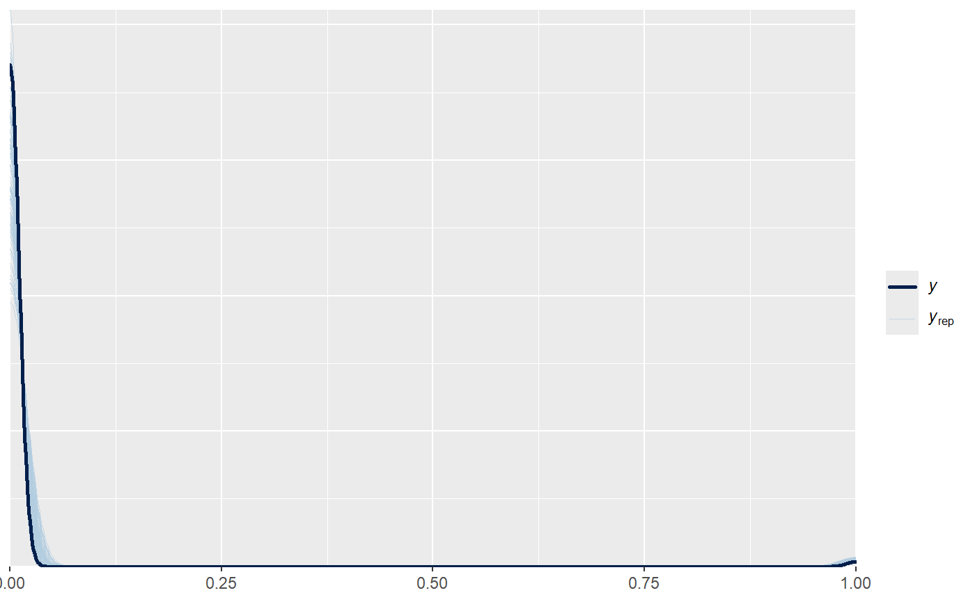
Eventuell sogar leicht zu optimistisch?

Column 5
Alt:
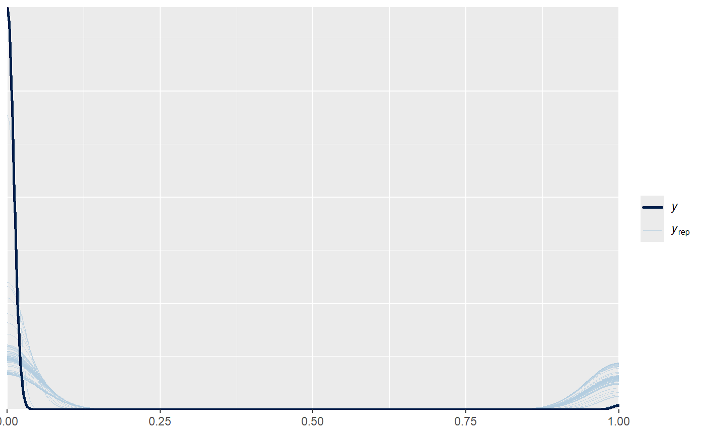
# playersprints goes from 0 to 12 (reduced effect to adjust for it having 12 units)
set_prior("normal(0, 0.1)", class = "b", coef = "playersprints_c")
We are saying that a player having ran 12 times in this section compared to zero changes the probability of scoring between (0.0009 ; 0.9975) so 0.1% to 10%.

Neu pp_check
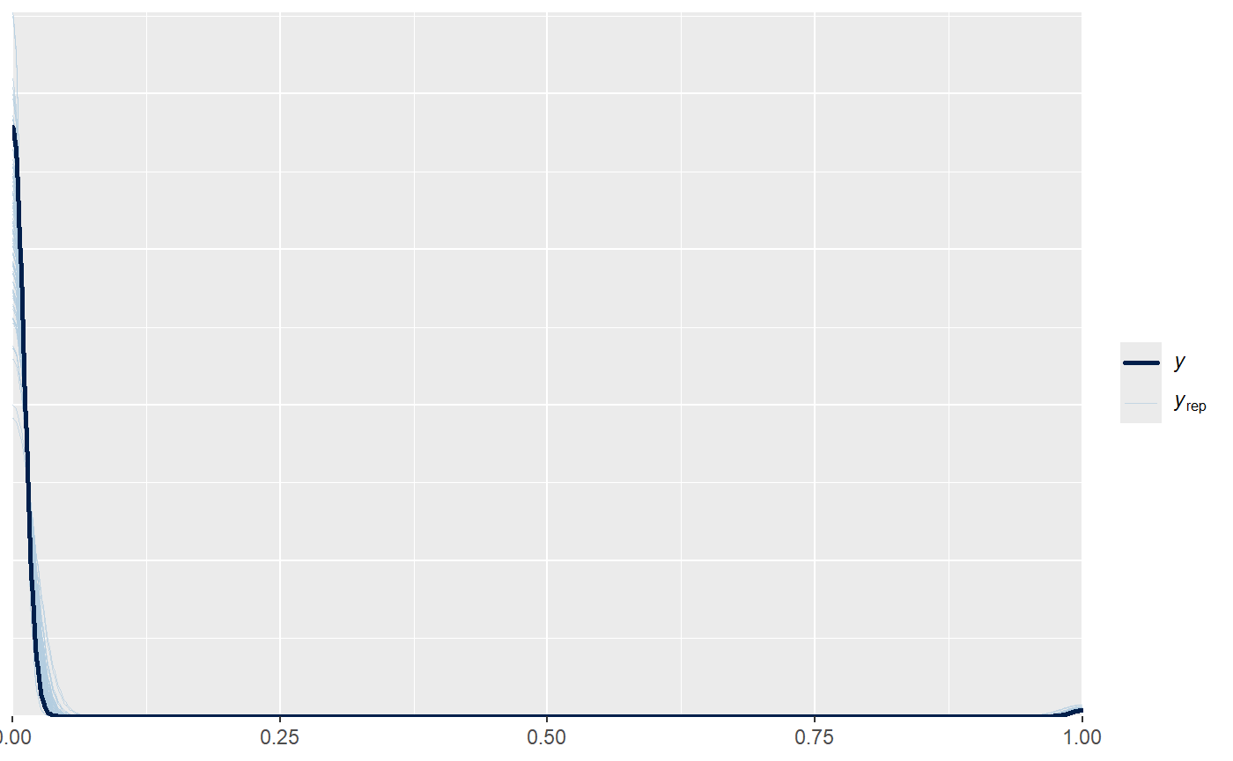
Column 6
Alt
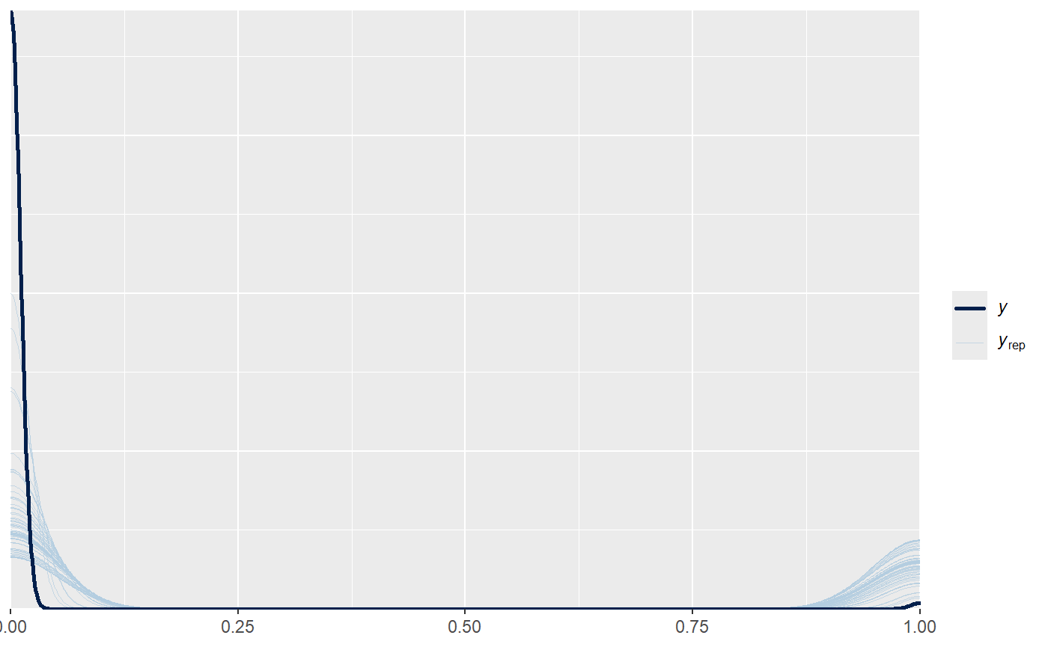
Neu
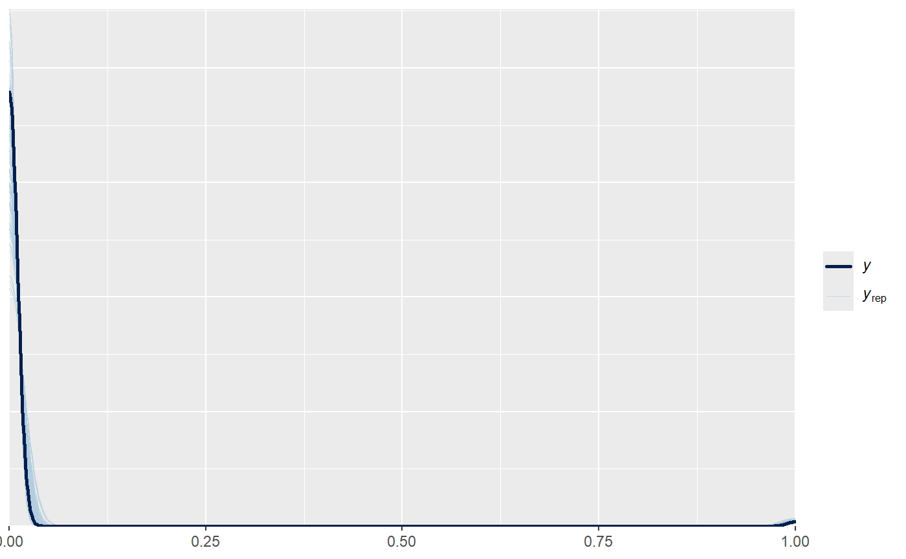

Column 7
Alt: looks alright but maybe the zeros are too common?
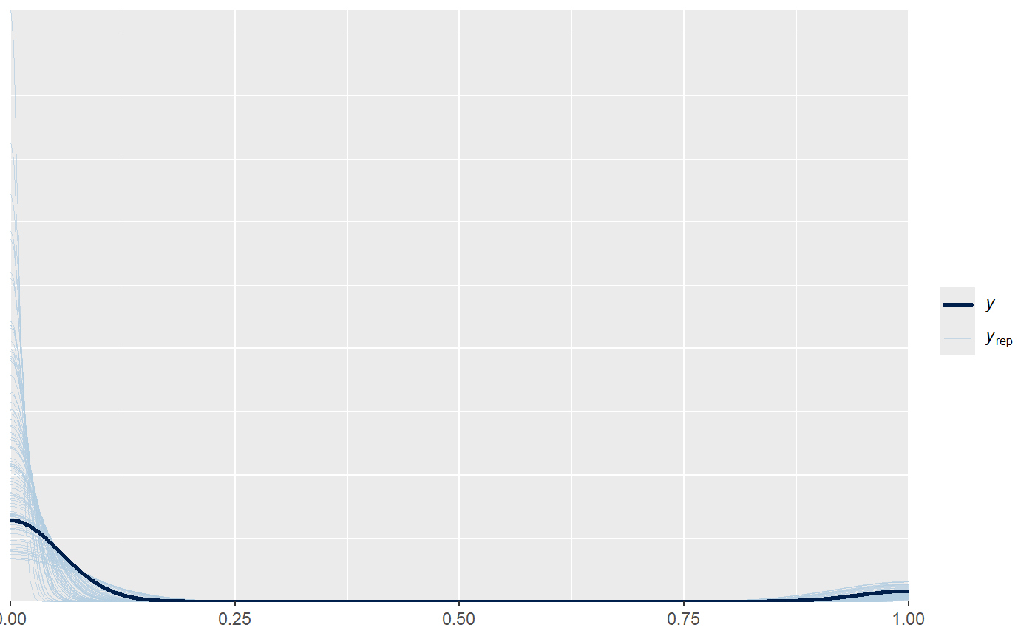
# Intercept (higher because we are on the game level now instead of 5 min section)
set_prior("normal(-2.2, 0.3)", class = "Intercept")
We are saying that the average probability for a goal in a game is around 10%. The mean was 11%. Every tenth game the avg. Forward or Midfielder scores, seems okay. I kept the variation the same as with section. I would tend to say the probability is likely lower than in a 5 min section, because most sections have 0 goals but most games don’t.

# general factors
set_prior("normal(0, 0.5)", class = "b")
all coefficients by default. We are saying the average factor tunring from 0 to 1 changes the probability from ( 0.039 ; 0.231) , so 4% to 23%

# plaavspeed_game goes from 2.6 to 10.2, around 8 units (change because of units)
set_prior("normal(0, 0.05)", class = "b", coef = "plaavspeed_game_c")
We are saying that increasing the average speed in the game from 2.6 km/h to 10.2km/h changes the scoring probability from (0.04742 , 0.1978) so from 4.7% to 20%.

#homegame
set_prior("normal(0, 0.5)", class = "b", coef = "dhomegame")
We are saying playing at home vs not playing playing at home changes the probability from ( 0.039 ; 0.231) , so 4% to 23%

#rankgap goes from -13 to 13 so 26 units (changed because of units)
set_prior("normal(0, 0.015)", class = "b", coef = "rank_gap_c")
We are saying playing with 13 ranks higher compared to playing with 13 ranks lower than the opponent changes the probability of winning from (0.0483 , 0.1946) so from 4.8% to 19.4%.

Neu: still looks plausible. A bit tighter but also more realistic with the intercept.
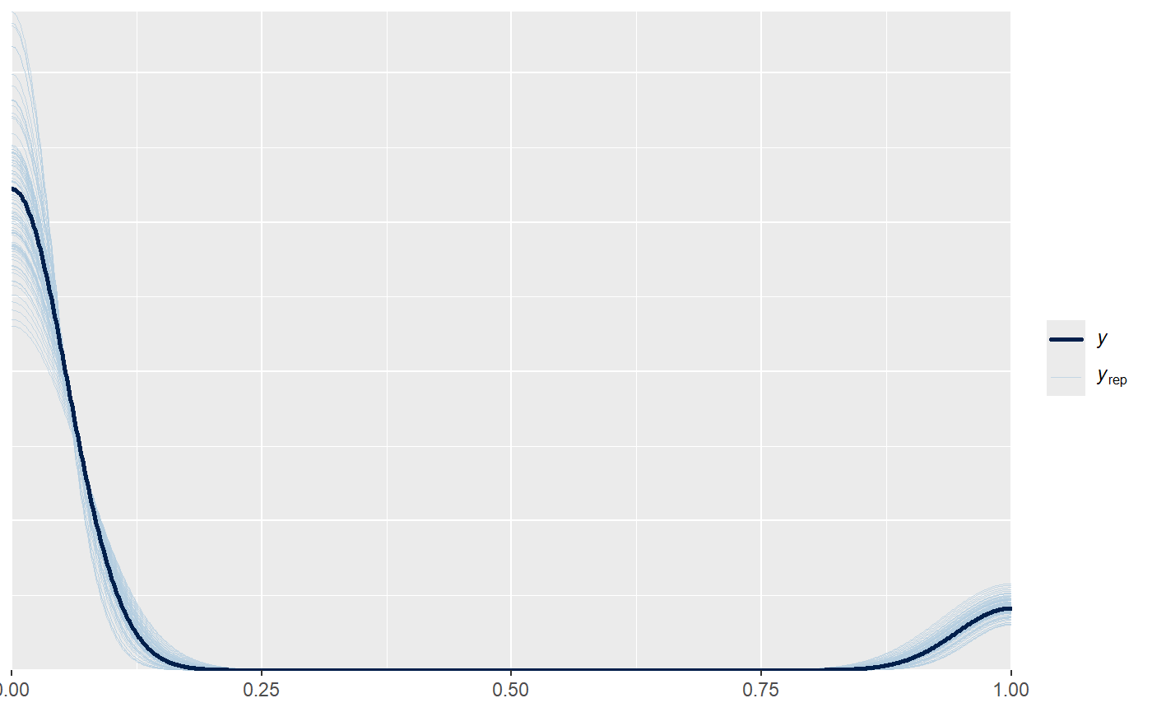

Table 3
Column 1
Alt: problematic, the blue lines don’t capture the data. The winning probability is consistently overestimated.
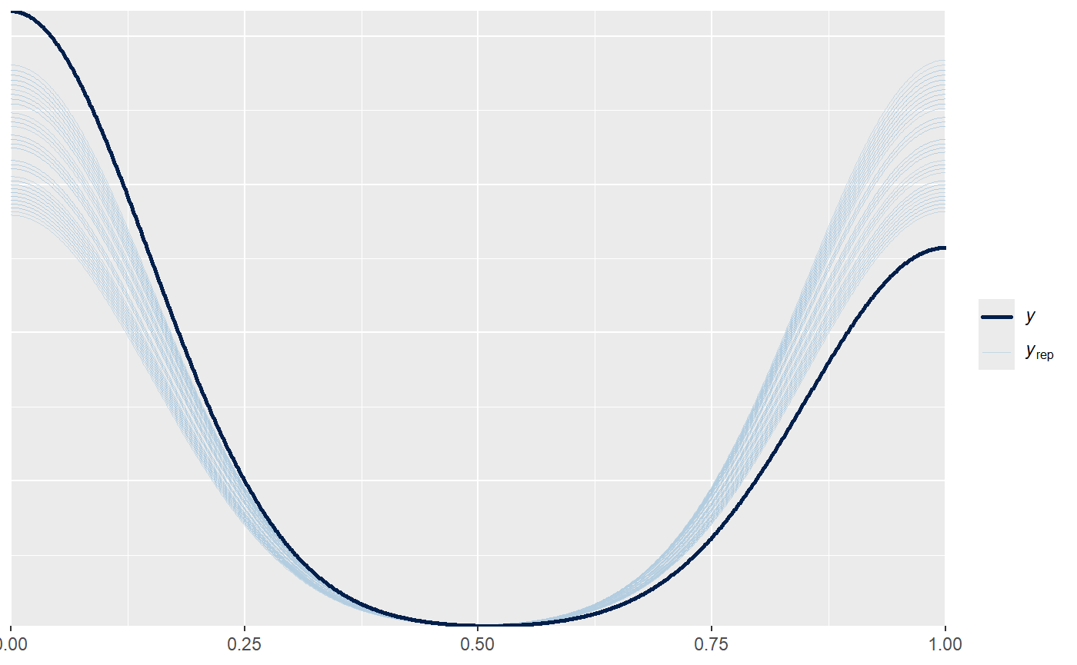
# intercept (change to reflect the avg of 38% and still capture the 5% and 95%, which are higher than the BO. The BO go from 6% to 77%, we believe each value of those should be captured.)
set_prior("normal(-0.48, 1.23)", class = "Intercept")
38% baseline chance, 95% of values will be between [0.05, 0.95], this is wider than the BO range of 6% to 77%

# teamdist_game goes from 19426 to 26649 so 7223 units (changed because of 7223 units)
set_prior("normal(0, 0.0001)", class = "b", coef = "teamdist_c")
we are saying that a team that runs 26.649km compared to a team that runs 19.426 will change the probability of winning between (0.12 , 0.72 ) so from 12% to 72%

#oppdist goes from 20514 ro 26515 so 6001 units (changed because of units)
set_prior("normal(0, 0.0001)", class = "b", coef = "oppdist_c")
we are saying that a team whose opponent runs 26.515 compared to a team that runs 20.514 will change the probability of winning between (0.15 , 0.67 ) so from 15% to 67%

Neu: There are some extreme values, but the data is fully captured by the priors.
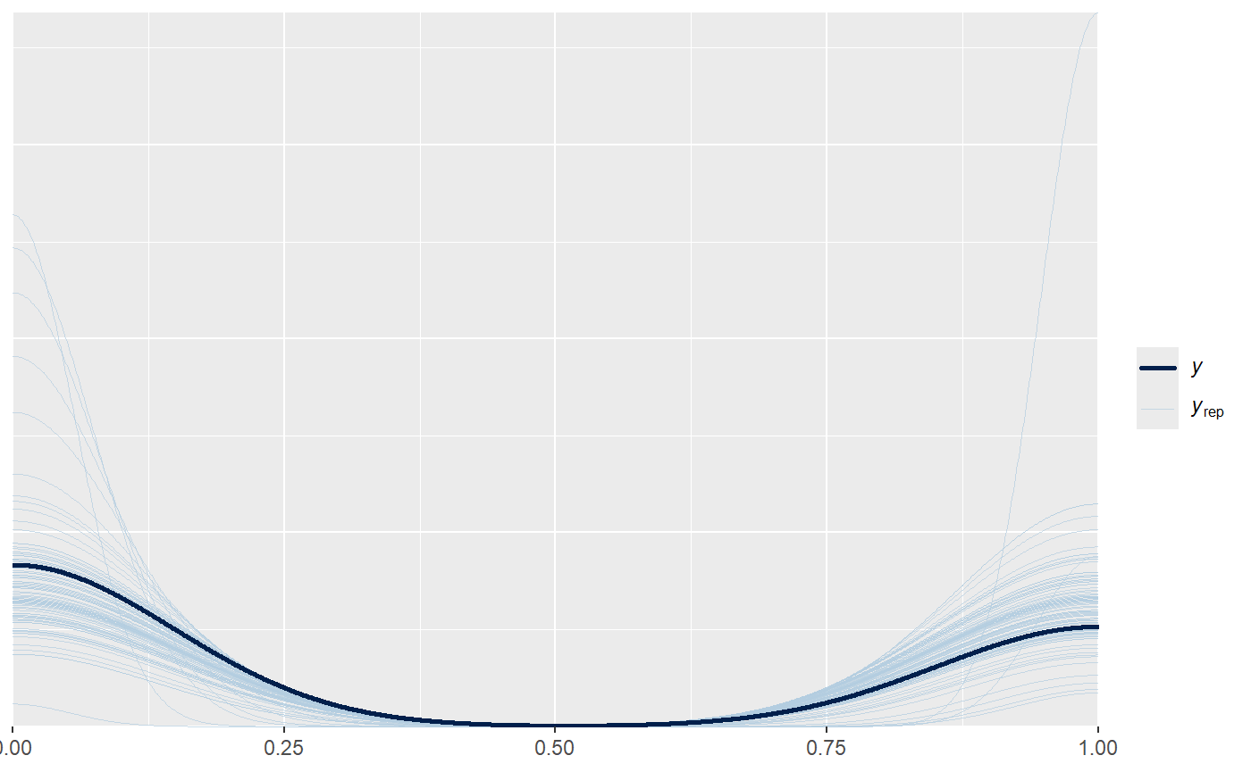

Column 2
# homegame hat aus 38% bis zu 80% gewinnchance gemact (reduziert)
set_prior("normal(0, 0.25)", class = "b", coef = "dhomegame")
We are saying that playing a home game or not changes the base probability of winning to be between ( 0.27, 0.505), 27% to 50%.

#rangegap goes from -13 to 13 so 26 unit (reduziert wegen units)
set_prior("normal(0, 0.025)", class = "b", coef = "rank_gap_c")
We are saying that being 13 ranks above your opponent compared to being 13 ranks under changes the odd around (0.14 , 0.69) from 14% to 69%.

Neu:
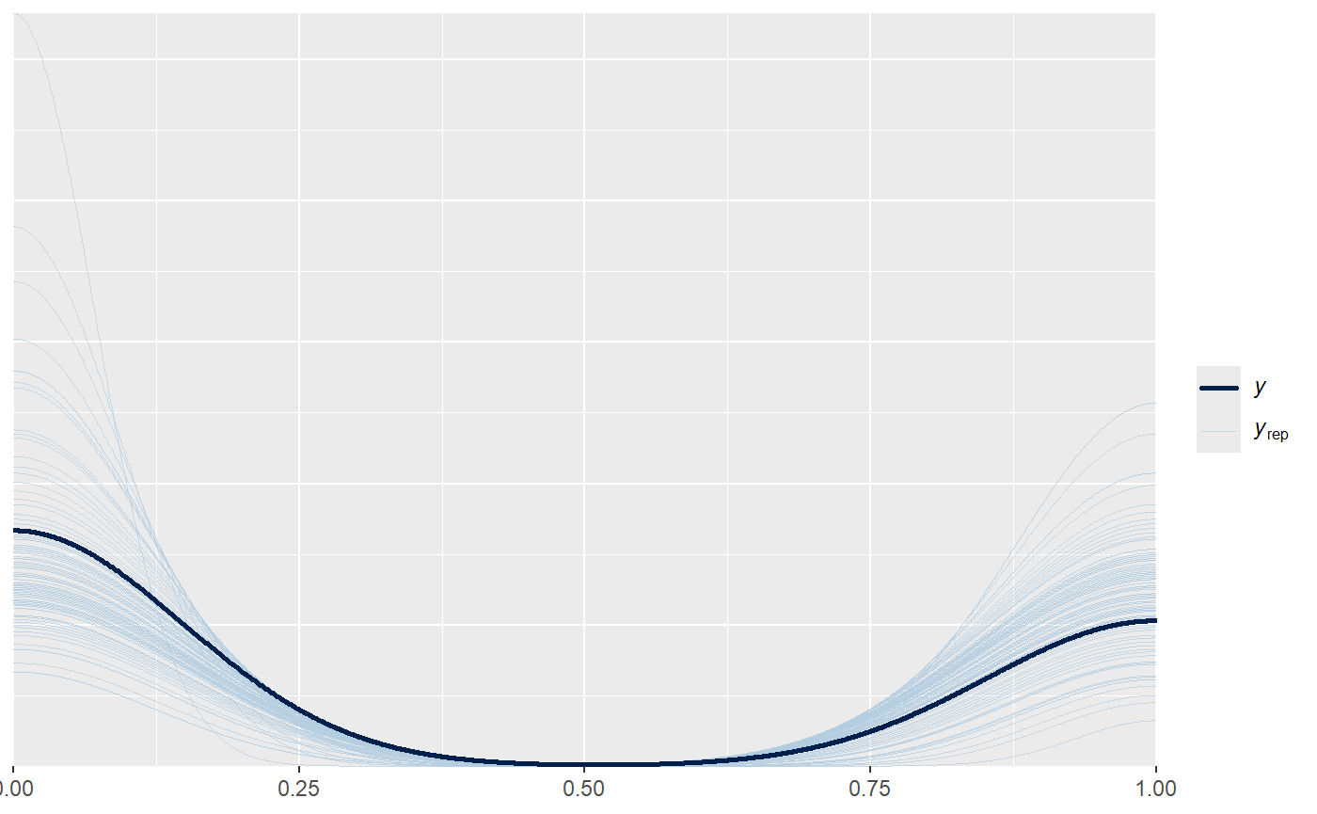

Column 3
Alt: Eigentlich nicht schlecht. Aber leicht über 1 und weil die anderen Funktionen nur mit dem neuen intercept gut aussahen, würde ich das hier weiterverwenden.
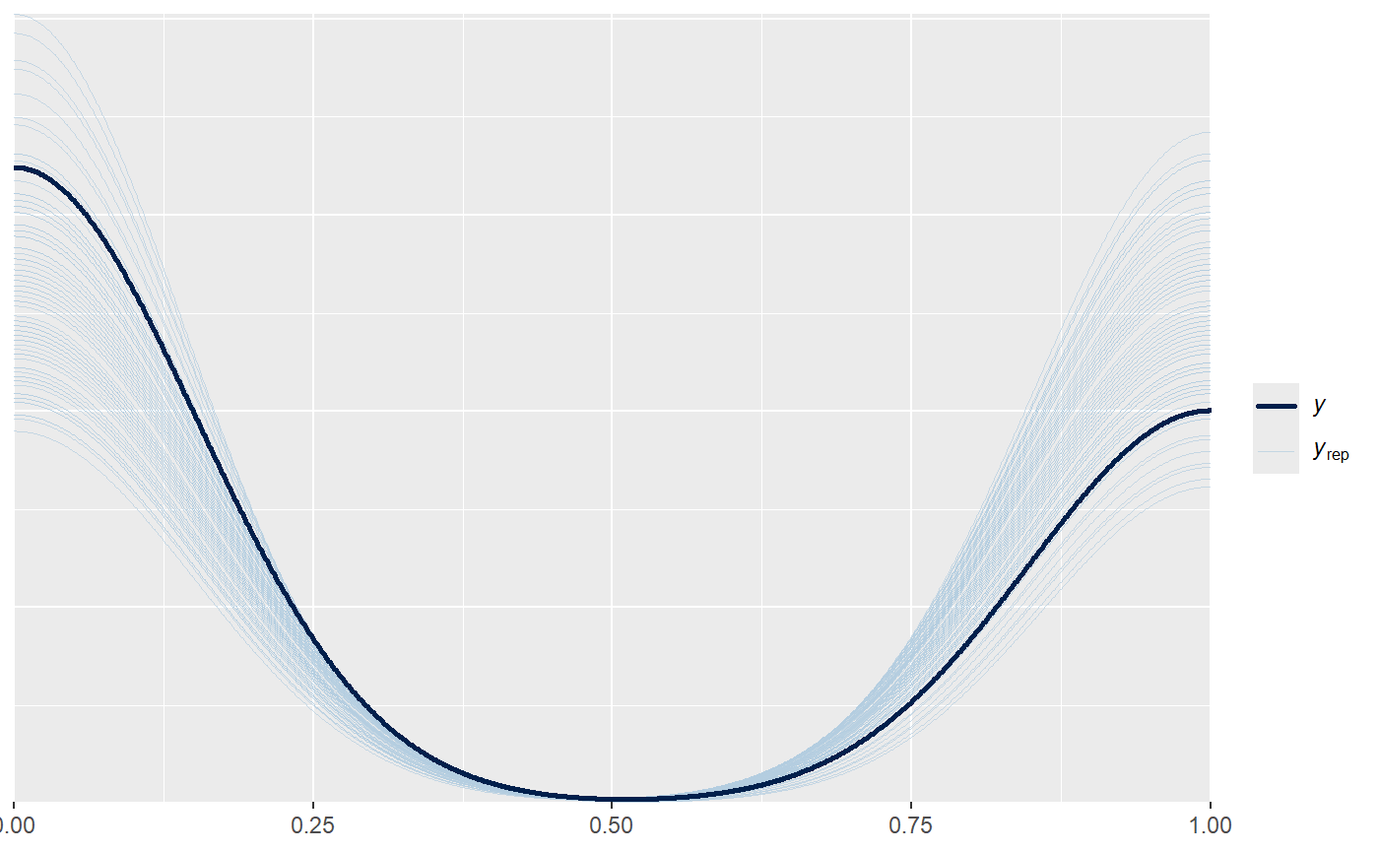

# teamcrowd goes from 8 to 24357 , 24349 units (verkleinert wegen units)
set_prior("normal(0, 0.000025)", class = "b", coef = "team_crowd_c")
We say by having a home crowd of 24357 compared to 8 the Values go from (0.15, 0,67) do 15% to 67%
#opp_crowd goes from 6 to 25180 (verkleinert wegen units)
set_prior("normal(0, 0.000025)", class = "b", coef = "opp_crowd_c")
Siehe teamcrowd

# p_odds_team goes from 0.06 to 0.77 unit ist 0.71. (vergrößert wegen units)
set_prior("normal(0, 2)", class = "b", coef = "p_odds_team_c")
Given the small unit of 0.71 the effect should reflect the odds. If your odds are 0.77 the probability of winning will lie between (0.03 ,0.91)

# p_odds_draw goes from 0.15 to 0.33 unit ist 0.18 (vergrößert wegen units)
set_prior("normal(0, 3)", class = "b", coef = "p_odds_draw_c")
If your probability of a draw is 0.33 compared to 0.15 the probability of winning will lie between (0.17 ,0.64) underdog or favorite.

Neu:
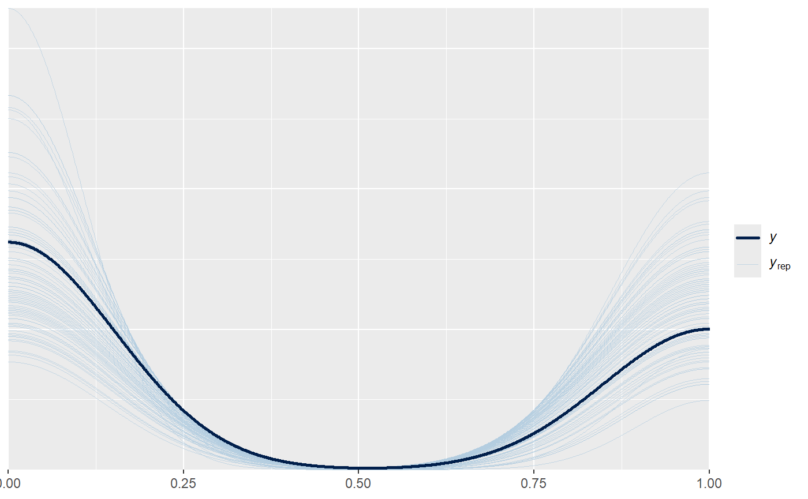

Column 4
Alt: Systematic overly likelihood of 1.
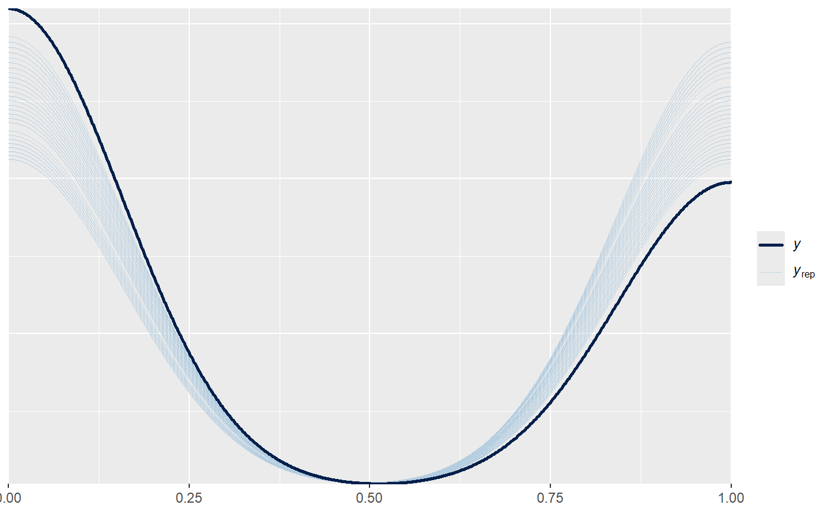

Neu:
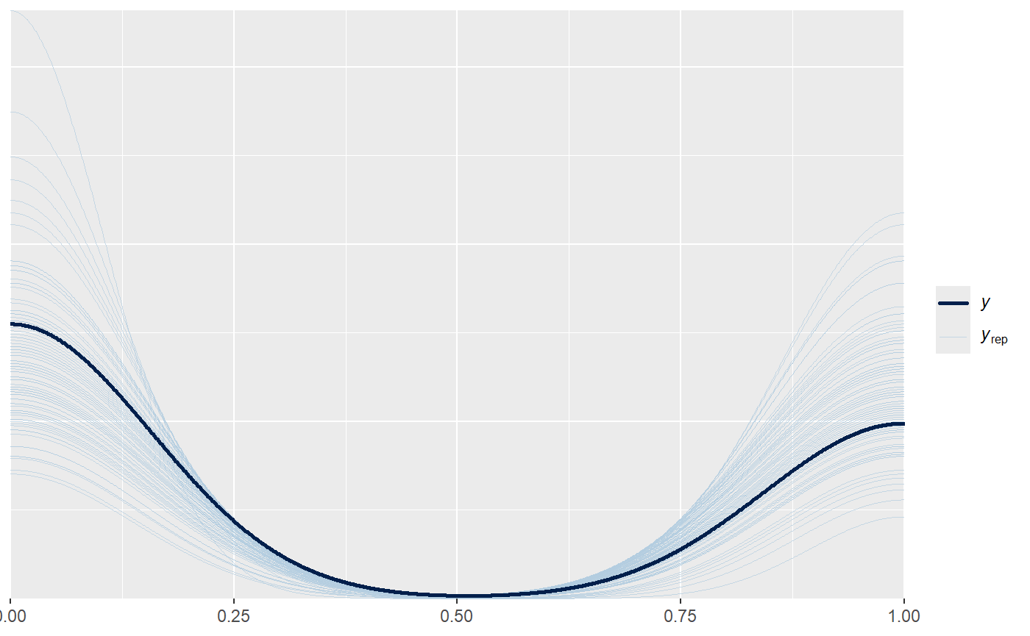

Column 5
Alt: eigentlich okay aber die vorherigen waren halt nicht okay mit diesen priors.
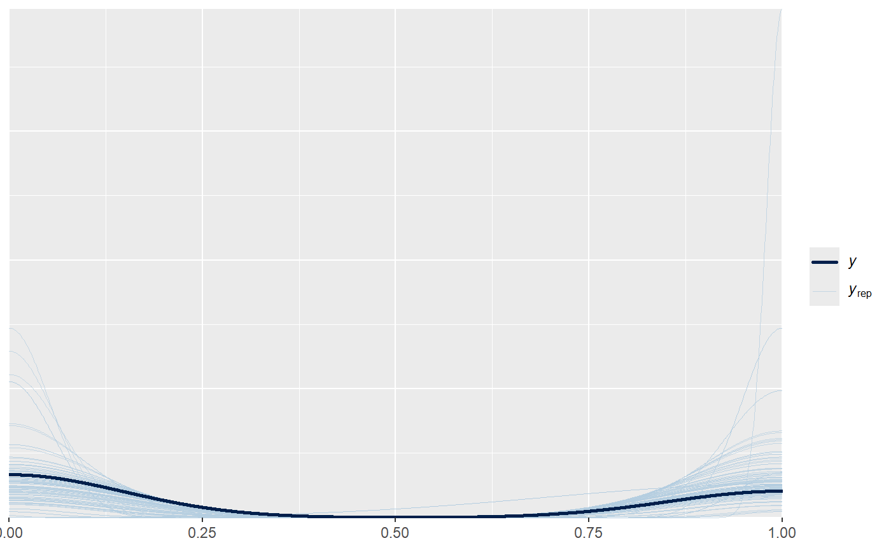
Modelle waren ohne intercept? Habe es hinzugefügt.

# distance_ratio geht von 0.89 bis 1.17. Sehr kleine units von 0.28. (erhöhen wegen Einheit)
set_prior("normal(0, 4.25)", class = "b", coef = "distance_ratio_c")
Wide weakly informative prior for our target variable. The ratio only moves by maximally 0.28 units, so this wide prior allows the effect to be between (0.05 and 0.86) so between 5% and 86%.
Neu:
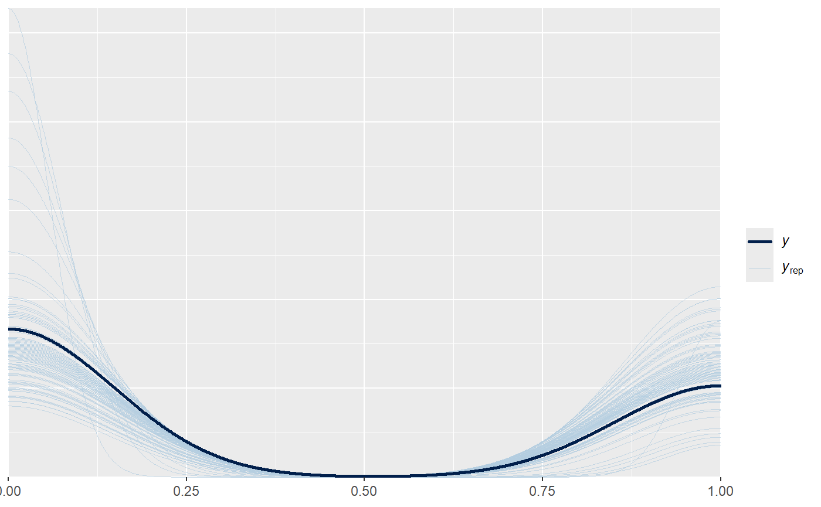
Column6
Alt: seltsam, so in klumpen irgendwie.
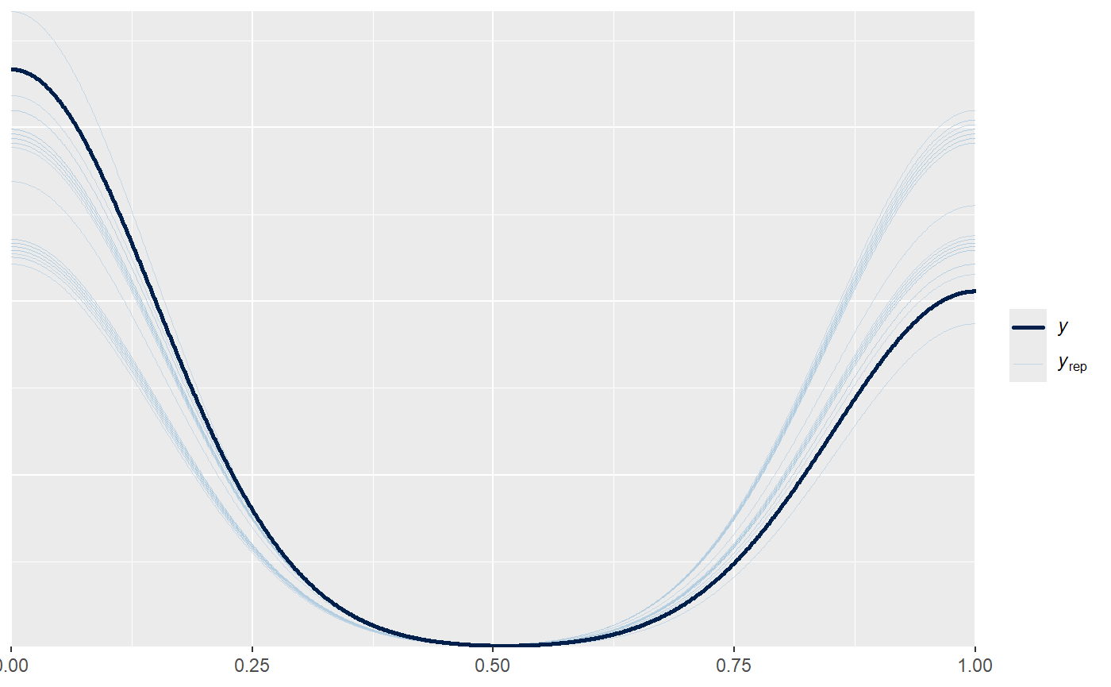
# total_distance goes from 40.158 to 52.316, so 5.977 units (decrease prior because of units)
set_prior("normal(0, 0.0001)", class = "b", coef = "total_distance_c")
Having run 52316 compared to having run 40158 can change probability to be between (0.15, 0.67) 15% and 67%

Neu:
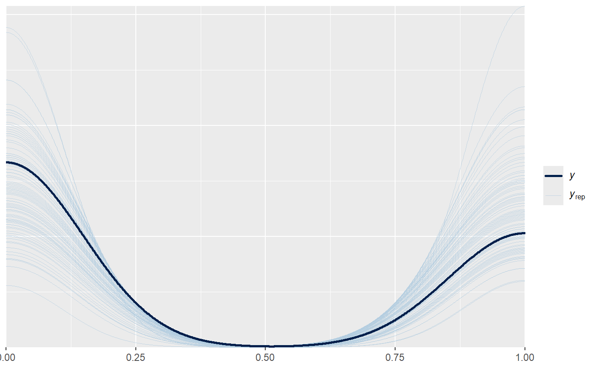

Logit-Link, Herleitung einer Formel für Prior setzen
We use weakly informative Normal priors centered at zero for regression coefficients. These priors regularize extreme estimates while allowing the data to dominate inference. The prior scale was chosen such that a two-standard-deviation change corresponds to a plausible change in outcome probability over the observed range of the predictor.
Given a baseline event probability of 1%, a two-standard-deviation change in the coefficient corresponds to an increase to approximately X%, which we consider a reasonable upper bound.

Aber was is X?
Quelle Buch:
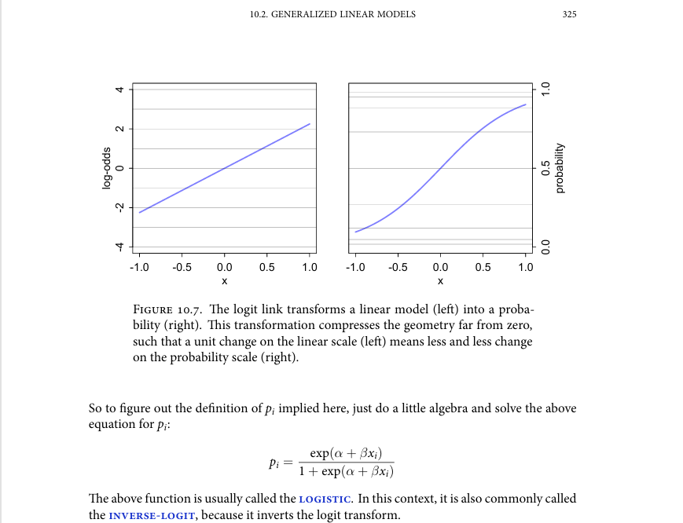

Formel 1:
$$p= \frac{e^{(α+βx)}}{1+e^{(α+βx)}}$$
$α$ = intercept (bei uns in table 2, 1%, $N(-4.6 , 0.3)$ also -4.6)
$β$ = coefficient value.

Given $N(0 , 0.04)$ the $β$ at the “two-standard-deviation change $2σ$ “range would be -0.08 or 0.08.

In die Formel gepackt heißt es bei x= 12 km/h (upper bound)
$$p= \frac{e^{\left(-4.6+0.08*12\right)}}{1+e^{\left(-4.6+0.08*12\right)}}=0.0255=2.55\%$$

Bei einem $N(0 , 0.4)$ prior heißt es bei x=12 km/h (upper bound)
$$p= \frac{e^{\left(-4.6+0.8*12\right)}}{1+e^{\left(-4.6+0.8*12\right)}}=0.993=99\%$$

Wahrscheinlich beides unrealistisch.
Idee, können wir eine Inversionsformel erstellen? Quasi wir wollen das der Effekt so viel ist, wie müssen wir dann die Priors setzen?
Ziel aus $p= \frac{e^{(α+βx)}}{1+e^{(α+βx)}}$ eine $f\left(p, α,x\right)= β$
Formel 2:
$$f\left(p, α,x\right)=\frac{\ln\left(\frac{p}{1-p}\right)-α}{x}= β$$
Beweis in Foto im Git Ordner.
Beispiel Rechnung:
$$p= 0.99330714907571514 ; α=-4.6 ;x=12$$

$$f\left(p, α,x\right)=\frac{\ln\left(\frac{0.993}{1-0.993}\right)-(-4.6)}{12}= 0.7962 ≈0.8 wie oben$$

Wir können mir dieser Formel also sagen wegen dem intercept -4.6 und der max größe der Werte, wollen wir diesen p wert. Die formel gibt uns das max beta, das wir setzen sollten.
Das gilt für alle Verteilungen, wir müssen nur je nach Verteilung das Sigma dann anders setzen. Bei normal sagt man ja $2σ$ sind ungefähr 95% der Werte, bei anderen Verteilungen halt andere.

Why even use Bayes for table 2?
At first glance, with nearly 50,000 observations, a frequentist approach may appear fully sufficient. In a narrow sense, this is true: point estimates will be similar, as the likelihood is strong and largely dominates the posterior. However, frequentist inference stops at a point estimate. Bayesian inference does not. It yields a full posterior distribution, allowing directly interpretable statements such as: with 95% probability, the effect lies within this range. This is substantially more informative and practically useful than a p-value attached to a single estimate.
The distinction becomes critical once the structure of the data is considered. Fifty thousand observations do not imply fifty thousand independent pieces of information. The data are deeply hierarchical: players are nested within teams, actions occur within the same five-minute sections, and information is unevenly distributed across groups. While the referenced paper uses fixed effects with clustered standard errors, this is not equivalent to a hierarchical model. Fixed effects estimate group parameters independently and do not allow for partial pooling. Clustered standard errors only adjust uncertainty; they do not change point estimates and therefore do not correct unstable or extreme group-level effects.
Bayesian multilevel models explicitly model this structure. Through partial pooling, estimates are stabilized by borrowing strength across groups, shrinking extreme values, especially in sparsely observed groups, and producing uncertainty that reflects both within- and between-group variation. Importantly, this means the estimates themselves change in a principled way, not just their standard errors.
Beyond estimation, Bayesian methods allow direct assessment of generalizability using tools such as LOO cross-validation, enabling systematic comparison of predictive performance across models, something that is not addressed in the frequentist framework used in the paper. Finally, priors and prior predictive checks force explicit modeling assumptions and allow us to assess whether our understanding of the problem is coherent even before observing the data.
Bayesian models are computationally more demanding. In return, they provide stabilized estimates, interpretable uncertainty, improved generalization, and greater transparency. With complex, hierarchical data, this is not an unnecessary complication, it is the approach that matches the structure of the problem.
Dann müssen wir diese dinger nutzen
- Model with partial pooling (hierarcial instead of fixed effects.)
- Prior only predictive check, show its great
- Posterior credible interval for “effort” speed coefficient, show its different than 0. Mcmc_areas() plot
- Loo comparison of a tables models

How we got the hebrew names:
2017–18 Israeli Premier League - Wikipedia as a source for the final standings of the regular season. With those, the “team_rank” variable before the 27nth game, which also had a variable “played” (one game after the regular season because the variable shows the rank going into the game) we were able to match the names to the team variable.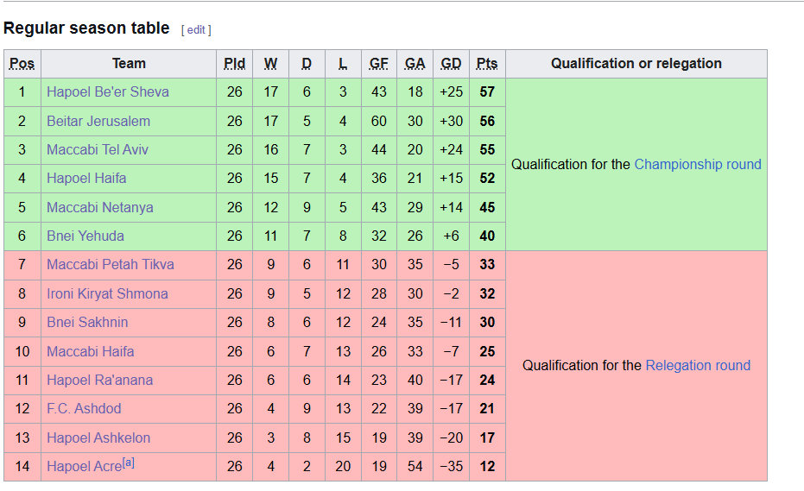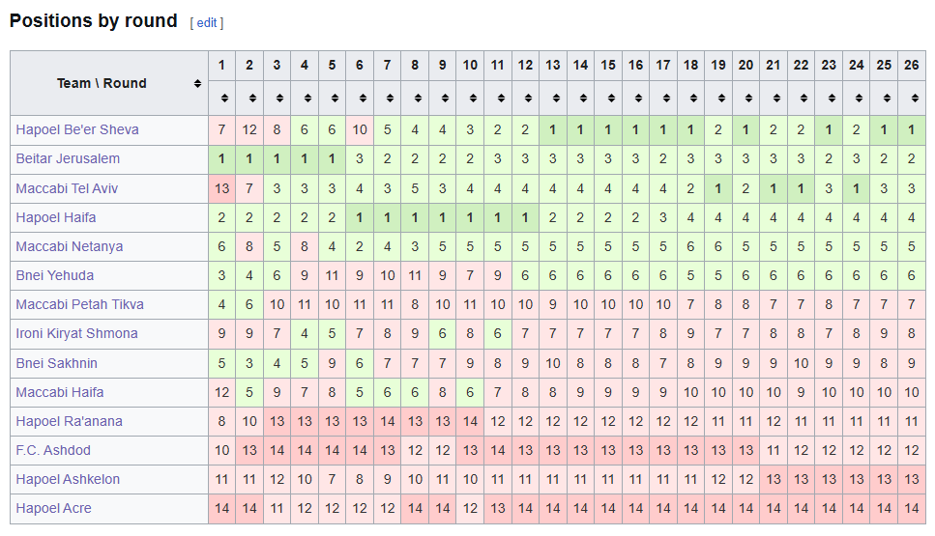

Introduction

EDA & Replication 1

- Describe main variables of interest (explaining and explained) and plot interesting relations (e.g., potential DAG’s or descriptive analysis)
- Replication I: Summary statistics
- Possible extension of Summary statistics

Replication 2

- Replication of main statistical model(s), Table 2 & 3
- Describe statistical model(s) with all priors and how replication is done in a Bayesian way
- Elaborate on your choice of a final model (e.g., prior & posterior predictive checks).
- Justify every part of your statistical model

Model evaluation

- Compare your model to other models – more complex or easier ones (e.g., information criteria or similar)
- Discuss model selection (which model is best and why?)

Conclusion

- Summarize results and conclude

